1. 
2. Sometimes, we return a value from a task.
3. 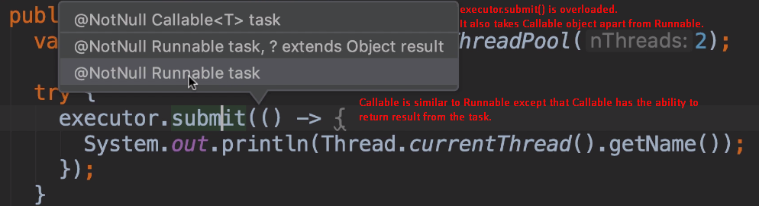
4. **Callable**: Very similar to Runnable. But this interface represents a task that returns a value. 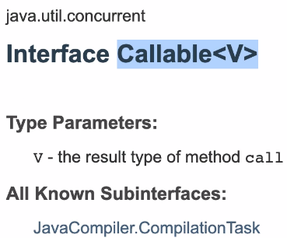
5. 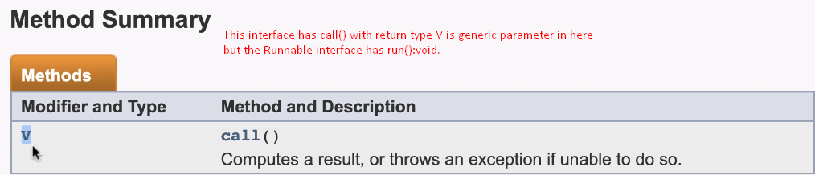
6. 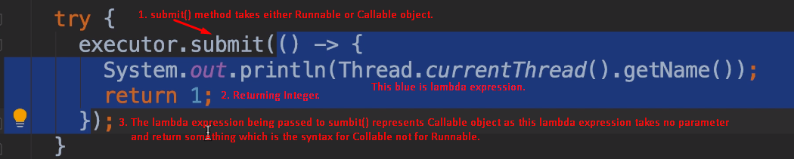
7. java.util.concurrent.Future<Integer>: This Future is an interface that represents the future result on an operation. That operation that we complete in future in 5 milliseconds, or 5 seconds etc. So the result of this operation is not calculated immediately using CPU.
8. To make this demo more interesting, let’s simulate a long running operation.
9. 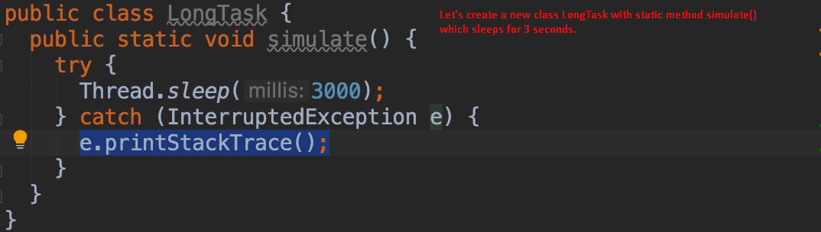
10. 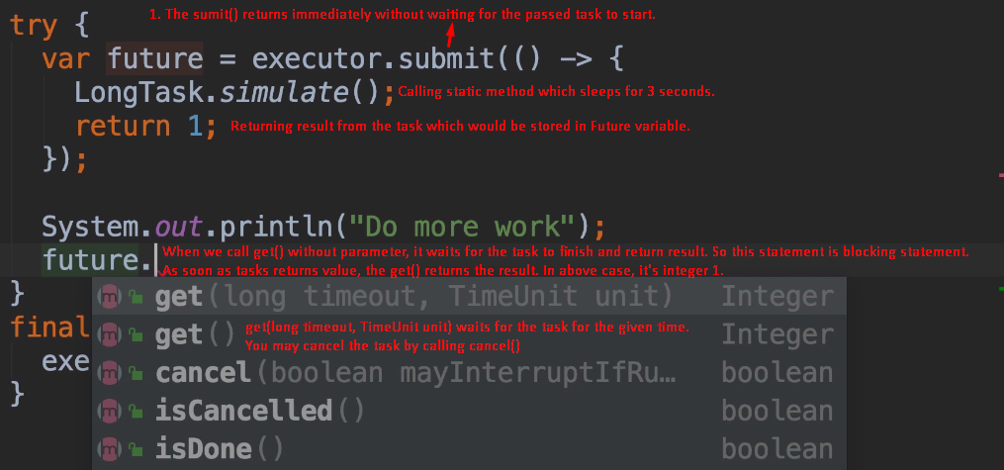 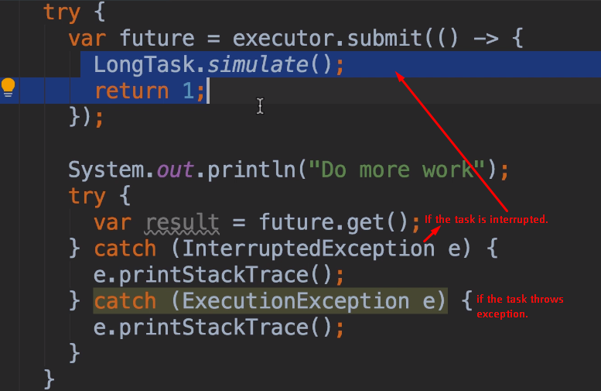
11. 